Bjarne Stroustrup
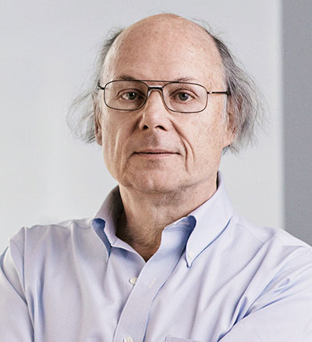
A Biography
“Design and programming are human activities; forget that and all is lost.

Who is Bjarne Stroustrup

Bjarne Stroustrup is the designer and original implementer of C++ as well as the author of The C++ Programming Language (Fourth Edition), A Tour of C++, Programming: Principles and Practice using C++ (Second Edition), and many popular and academic publications. Dr. Stroustrup is a Managing Director in the technology division of Morgan Stanley in New York City as well as a visiting professor at Columbia University. He is a member of the US National Academy of Engineering, and an IEEE, ACM, and CHM fellow. He is a recipient of IET's Faraday Medal. His research interests include distributed systems, design, programming techniques, software development tools, and programming languages. He is actively involved in the ISO standardization of C++. He holds a masters in Mathematics from Aarhus University and a PhD in Computer Science from Cambridge University, where he is an honorary fellow of Churchill College.
Early Life and Education
Stroustrup Studied mathematics and computer science in the university of Aarhus Denmark in 1975. He then went on to complete a Ph.D. in computer science at the university of Cambridge England. His advisor at the time was David Wheeler who was most Known for his early work on first computers.
His Work and Contributions to Computer Science
Stroustrups biggest contribution to Computer science and software information has been his implementation and creation of the language C++(1985). Stroustrup began work on the language in 1979. He first had the idea for this language when he was writing his Ph.D. Thesis. Stroustrup was beginning to see emerging labguages that were very good for large software projects that incorporated class systems but were still inefficient for use in the real world. This paired with languages that were excellent in low level performance such as C or BCPL but were difficult to implement and alter in real world situations. This sparked his idea for C++ originally coined as “C with Classes”. Adding new features such as: classes, derived classes, strongtyping, inline and default arguments. This was all released in the first version. In later editions after popularity increased features such as multiple inheritance, abstract classes, static member functions, const member functions, protected members, templates, exceptions, namespaces, new casts, and a boolean type.
C++ change the software industry in a big way by enabling a variety of software development techniques-including object-oriented programming, generic programming, and general resource management-to be deployed at scale. C++ has been one of the most popular languages for more than 2 decades and has had a huge impact with applications in areas including general systems programming, communications, computer graphics, games, user-interfaces, embedded systems, financial systems, avionics, and scientific computation. Even if you see C++ as a non-perfect language, it definitely sparked a coding revolution in making more efficient languages and also making them more accessible for new programming practices.

His Views on what C++ Has Achieved.
The adoption of C++ has been extremely widespread. It has seen performance increases in a wide variety of fields in a wide variety of companies. Anything from BMW cars to jet fighters Have been seen to adopt C++ as a more efficient code base for their systems. Apart from all this, many companies have adopted it as a language for their backend servers. Examples such as google search engine or even Facebook who switched to C++ as they needed to build a more powerful system. Stroustrup without even realizing it at the time saved a severe amount of resources by halving server farms needed to run these massive company platforms. He later viewed this as a step in the right direction for energy efficiency and combatting climate change.
In-text: (Big Think, 2017)

Career
In 1979, Bjarne Stroustrup, together with his wife and daughter, moved to New Jersey to join the Computer Science Research Center of Bell Telephone Laboratories (colloqually know as 127 or 1127). Over the years, they lived in Summit, Meyersville, and Watchung - all about 10 minutes drive from Bell Labs' main research site in Murray Hill. A son, Nicholas, was born in Meyersville. After the 1984 break-up of the Bell System, Bell Labs became AT&T Bell Labs, and after the 1995 break-up of AT&T, AT&T Bell Labs was itself split into AT&T Labs and Lucent Technologies Bell Labs. From its inception, Bjarne was a member of AT&T Labs - Research, the half of Bell Labs Information Sciences Research that AT&T kept to itself as Lucent and NCR were spun off.
Bjarne was the head of the Large-Scale Programming Research Department from its creation in AT&T Bell Labs until late 2002 when he joined the computer science department of Texas A&M University. He retained a link with AT&T Labs - Research as an AT&T Fellow until 2012.
From 2002 to 2014, Bjarne was the College of Engineering Chair in Computer Science Professor at Texas A&M University. He and his wife lived in a house in a quiet wooded area of College Station, Texas. After leaving for NYC in January 2014, he retains a link to TAMU as a University Distinguished Professor. He is a member of the Parasol group in the Computer Science and Engineering Department.
Future Plans
In-text: (Stroustrup.com, 2017)
Your Bibliography: Stroustrup.com. (2017). Stroustrup: Biographical Information. [online] Available at: http://www.stroustrup.com/bio.html [Accessed 9 Nov. 2017].

In-text: (Computerhistory.org, 2017)
Your Bibliography: Computerhistory.org. (2017). Bjarne Stroustrup | Computer History Museum. [online] Available at: http://www.computerhistory.org/fellowawards/hall/bjarne-stroustrup/ [Accessed 9 Nov. 2017].

In-text: (Big Think, 2017)
Your Bibliography: Big Think (2017). Bjarne Stroustrup: How C++ Combats Global Warming. [image] Available at: https://www.youtube.com/watch?v=FBWeO2HYEc0 [Accessed 9 Nov. 2017].

